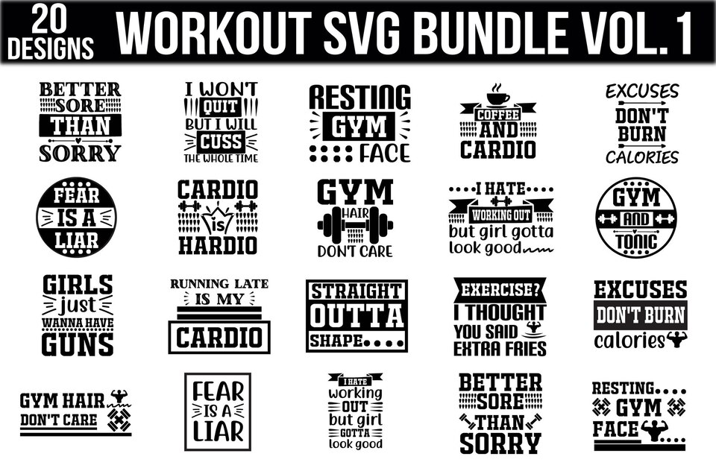

# [How to Use the Liteboxer Fitness Bundle :](https://theraputicmanifesto.com/how-to-use-the-liteboxer-fitness-bundle/)

Exercise is an essential part of our life. Some people tolerate it, but they don’t reduce their calories. Nowadays, there are many things that people can do to lose weight quickly. **LITEBOXER fitness bundle** is a plan that thoroughly guides you in terms of your fitness. And the most important thing is that it is straightforward to use and keeps you fully informed about your fitness. You can sweat your body fat anytime, anywhere, with the help of this fitness. You can quickly reduce your body fat with the help of this fitness bundle.  
Many people exercise but are unsatisfied because they add calories instead of burning them, leading to anxiety. But now you don’t need to worry because this fitness bundle helps you in every way. It gives you solutions for all your problems.